**(EEL2020)** **DIGITAL DESIGN LAB3 REPORT**

KARTIK CHOUDHARY B20CS025

**Work 1:** **Modify the Four Bit Adder created in Lab 1 to implement an Adder-Subtractor Unit.**

a) Indicate overflow  
b) Modify the unit to implement a comparator.  
c) Test using the test benches

*Test bench*

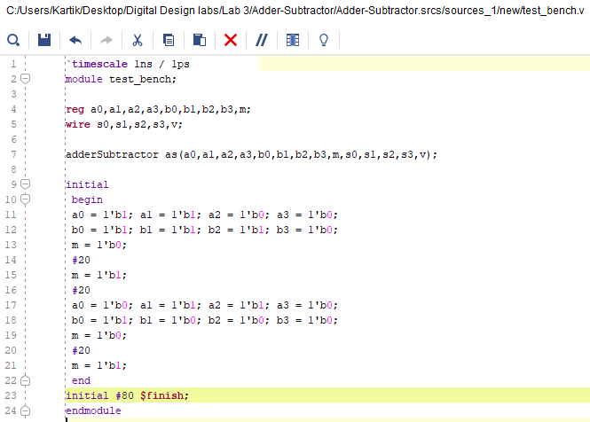

*Verilog Code*

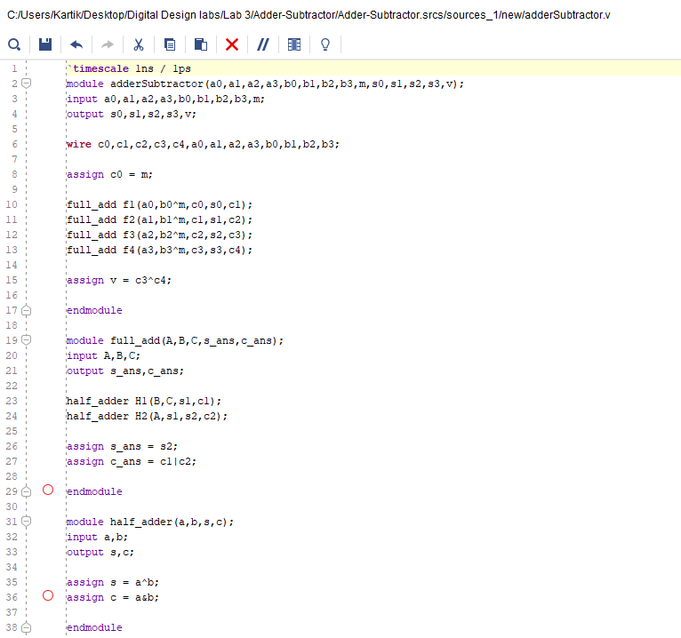

*Waveform*

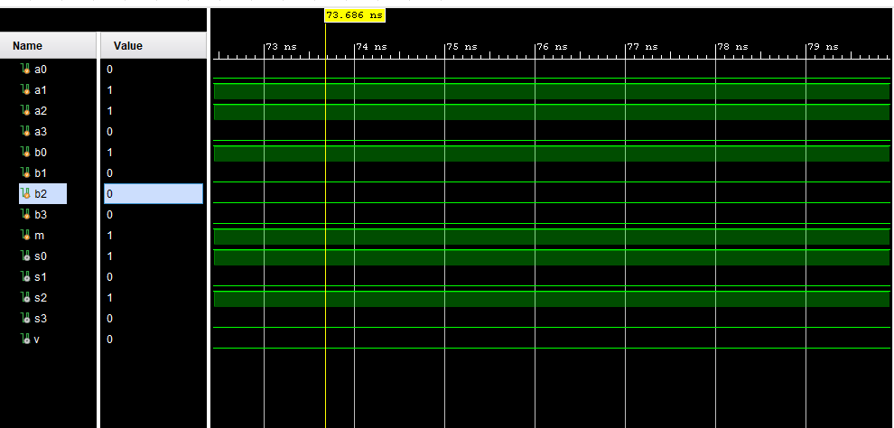

COMPARATOR

*Test Bench*

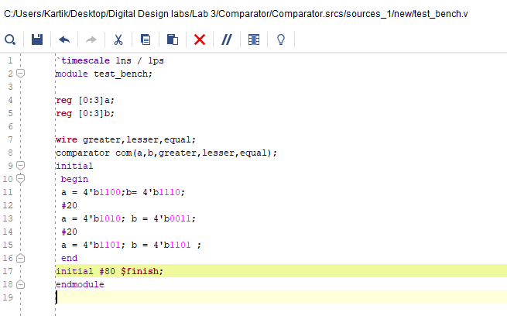

*Verilog Code*

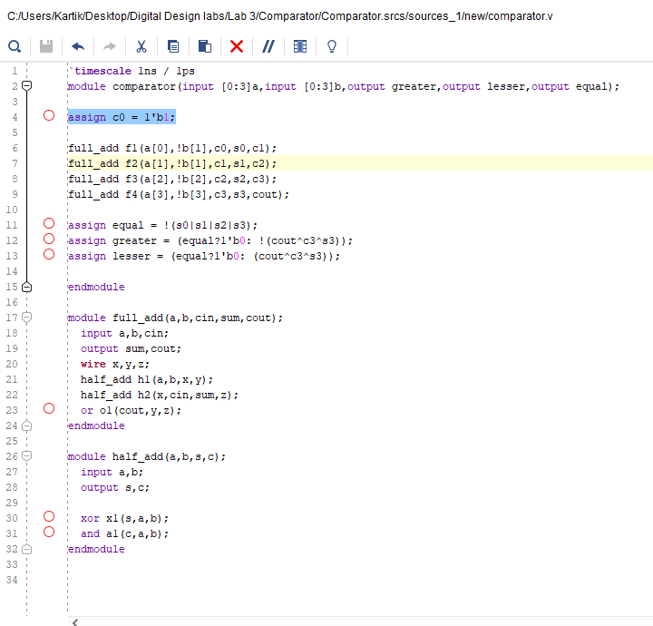

*Waveform*

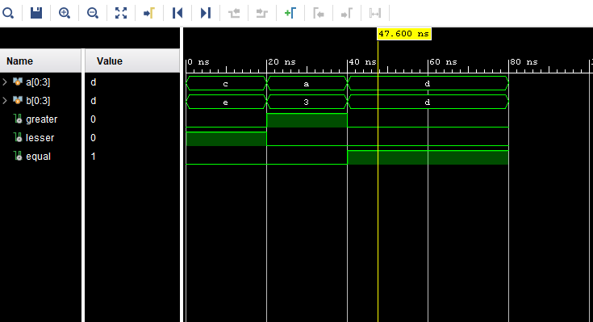

**Work 2: Write a Program to Implement the following Fast Adders [32 bit]**

a) Carry Look Ahead Adder

*Test Bench*

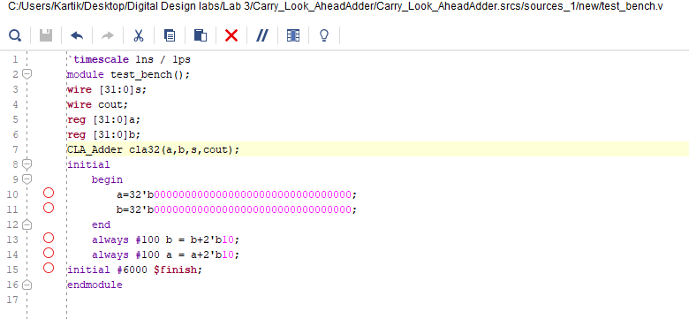

*Verilog Code*

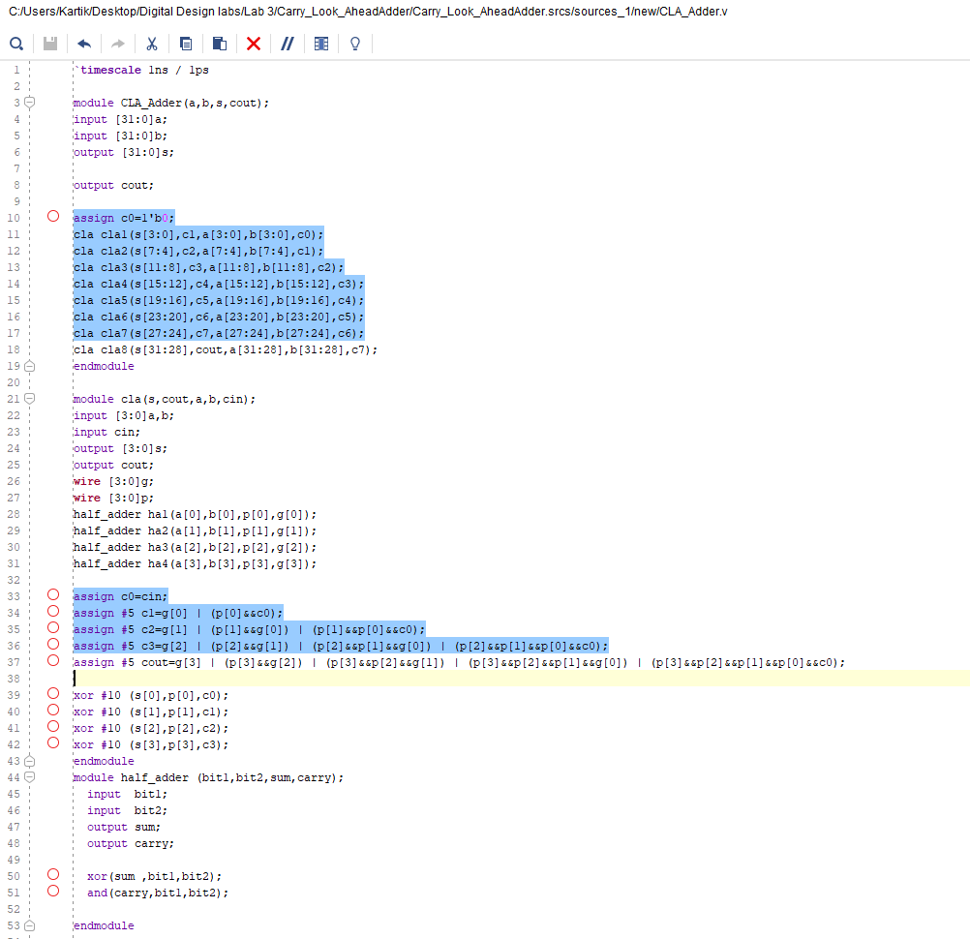

*Waveform*

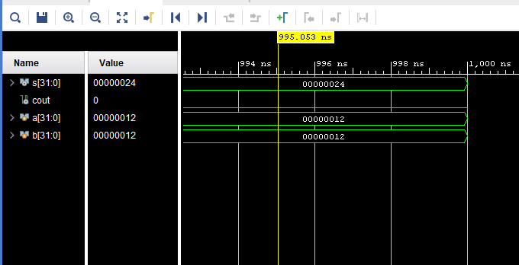

b) Carry Skip Adder

*Test bench*

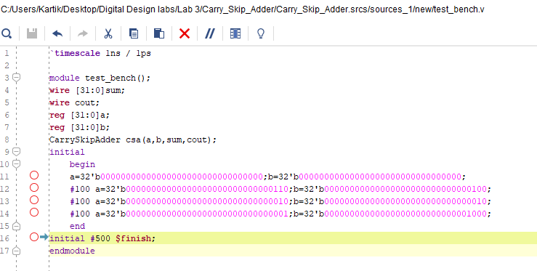

*Verilog Module*

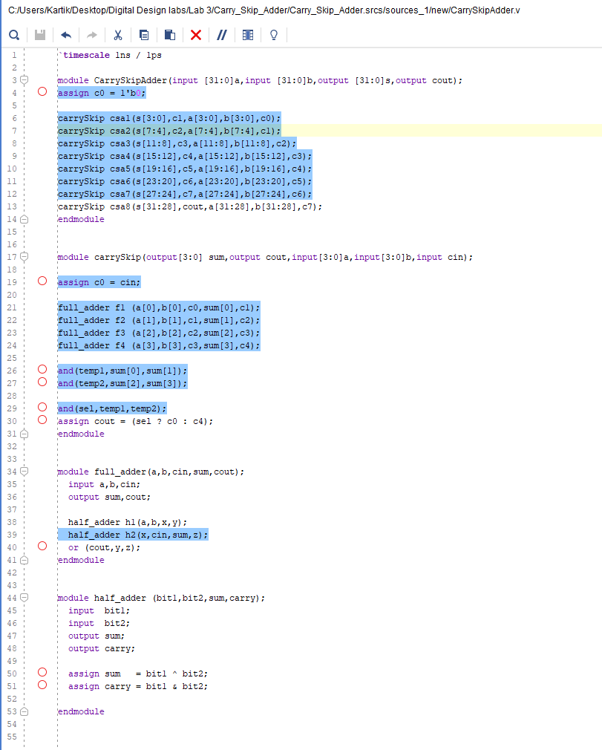

*Waveform*

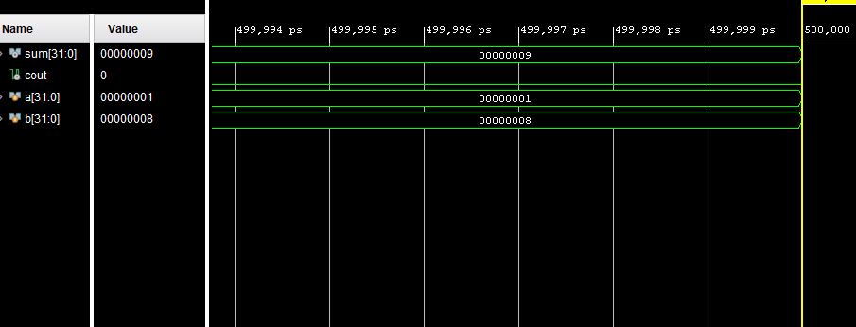

c) Carry Select Adder

*Test Bench*

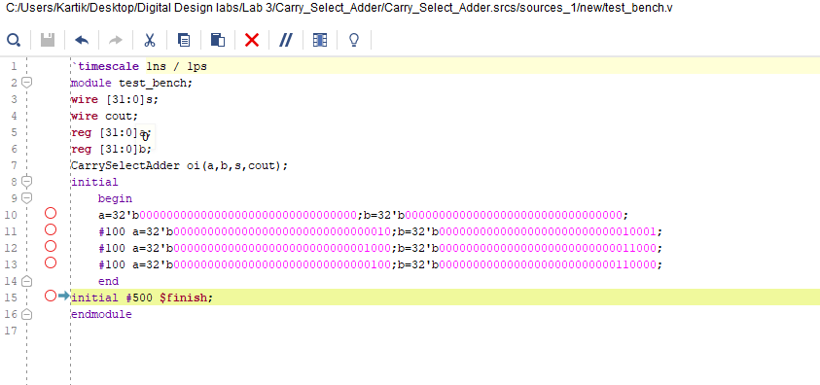

*Verilog Module*

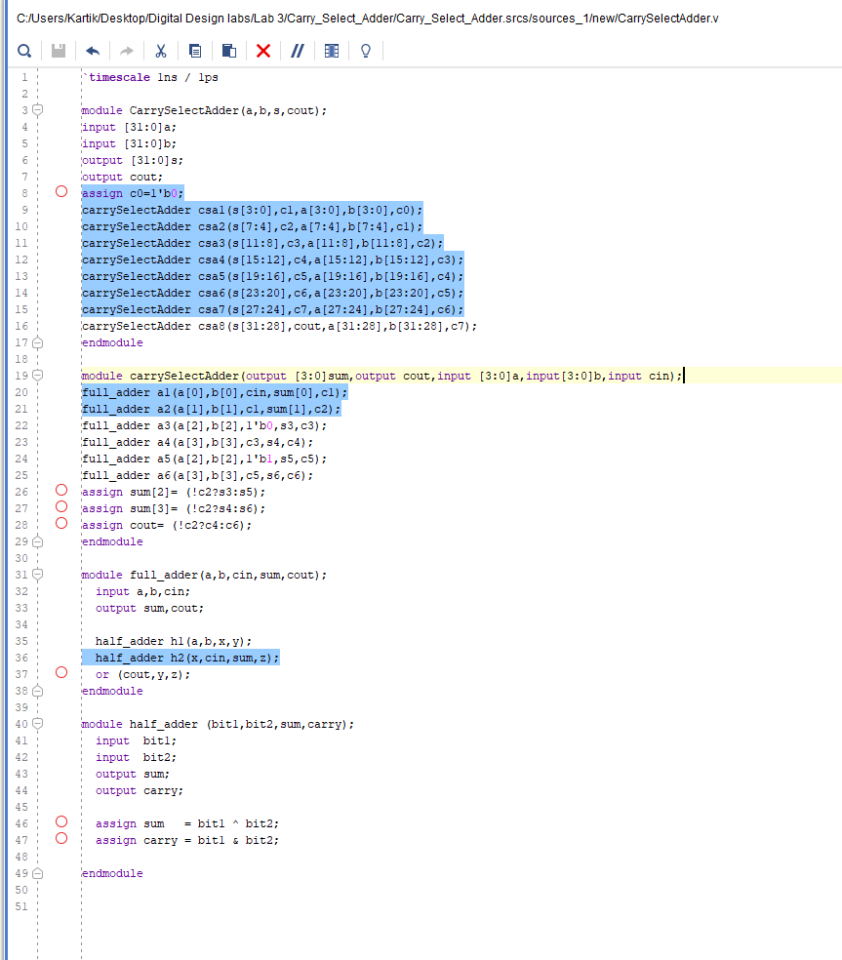

*Waveform*

